Title: Cohesion Policy
Subject: EEP 17

1. Idea  2. Assessment  3. Is Eu development following Solow predictions?  A. Solow Model  a. predictions  b. Results: across nations and among regions  4. Eu regions analysis, in deep  5. Can we explain Eu develop with New Economic Geography Theory?  A. Idea: Agglomeration forces vs Dispersion Forces  B. Overall balance  C. Effects of Eu integration  a. Theory  b. Empirical Evidence  6. Cohesion Policy  A. Idea  B. Instruments of the Cohesion policy 2021-2027  a. Regional Development Fund (226 bn)  b. Cohesion Fund (48 bn)  c. EU Social Fund+ (98 bn)  C. Cohesion Policy managment | The Treaty on the Functioning of the EU – art. 174:  In order to promote its overall harmonious development, the Union shall develop and pursue actions leading to the strengthening of its economic, social and territorial cohesion. In particular, the Union shall aim at reducing disparities between the levels of development of the various regions. Among the regions concerned, particular attention shall be paid to rural areas, areas affected by industrial transition, and regions which suffer from severe and permanent natural or demographic handicaps”  Inequality Between nations and among regions  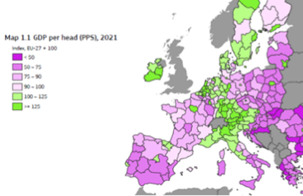  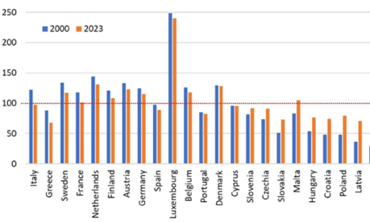  Between regions  Inequality, a core-periphery pattern: eu develop is concentrated in the core! = Geographical proximity matters. The eu development is giving more opportunities to areas proximat to the core (ex. Sicily vs Veneto)  Between nations: Inequality  What are the regional distribution effects of processes of economic integration?  SOLOW MODEL: IDEA  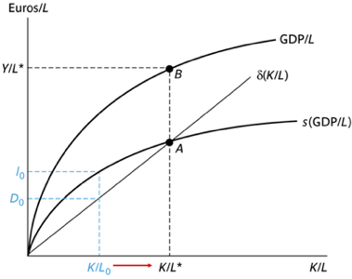  Neo-classical growth theory (Solow):  Solow claims there is decreasing marginal productivity of K.  With differences in initial endowments of K => In a Single Market, k would flow towards less-endowed areas, thus leading to:  β-convergence: initially poorer economic entities within a group grow faster than the richer ones.  σ-convergence: reduction in the dispersion of GDP per capita across a group of economic entities  Notice: β-convergence is a necessary condition for σ-convergence, though not a sufficient one (necessary to have a reduction in the overall dispersion). Viceverdsa not true!!!! See image.  RESULTS  β-convergence (we expected this due to sigma convergence was in place))  σ-convergence:  Convergence across regions: There is convergence, but very poor after 2008  Convergence between nations: yes. After 2008: still convergence even if less  Not clear for regions after 2008  *Note covid increased divergence  clear for countries  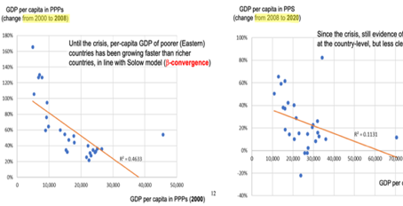  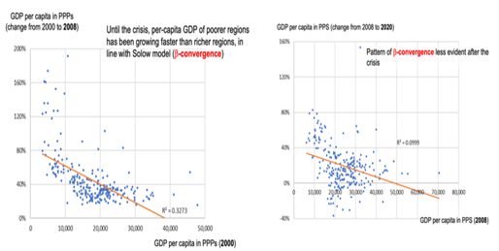  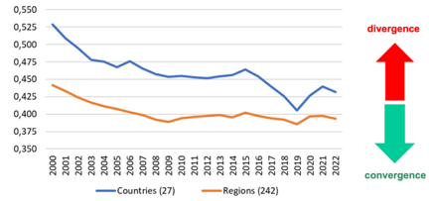  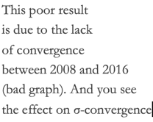  Overall example: think of Poland, strong growth driving cross-country EU convergence, but within-country regional divergence  Income dispersion across regions  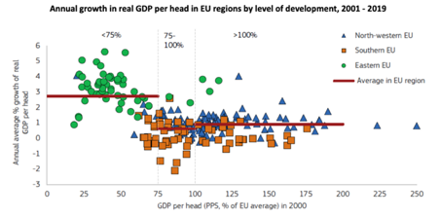  You would have expected three decreasing layers. Conclusions:  - <75% of the median group (Eastern Eu) is driving convergence  - Median group (southern eu) does not on average grow faster than the third => this is holdkng convergence bak!  Moreover, whitin each country regional inequality follows heterogenous paths:  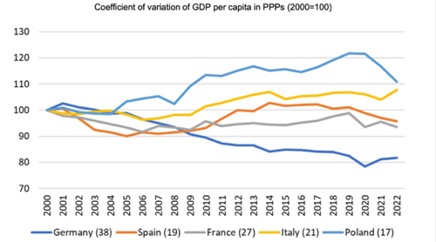  How can we rationalize conceptually a phenomenon whereby countries converge while regions diverge? We need another theory...  Evidence suggests a core-periphery path = Eu integration may be partly responsible for EU inequality.  New Economic Geography is based on two pillars:  A. Agglomeration forces encourage spatial concentration:  - demand linkages: better stay close to big markets to reduce tarde costs  - cost linkages: availability of suppliers (if you are close lower transportaiton costs).  B. Dispersion forces favor the geographic dispersion of economic activity (e.g., higher rent and land prices, high cost of services, pollution and congestion costs, competition with other firms)  Note, agglomeration forces are self reinforcing:  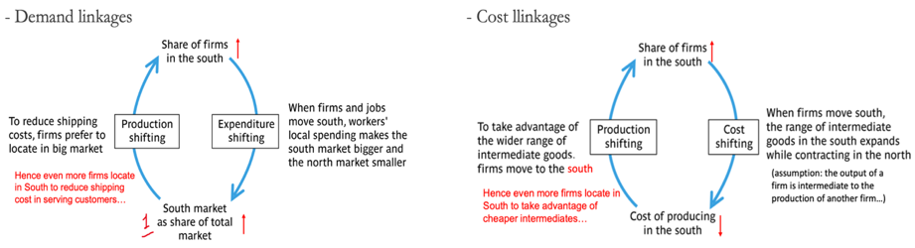  The balance between agglomeration forces and dispersion forces will determine the observed allocation of economic activities. Any shock to the relevant forces (tech, institutional, infrastructure, transport costs) may change this allocation... here we focus on the effects of eu integration.  Eu integration affects agglomeration and dispersion forces and thus the core-periphery pattern in complex ways.  Key: it reduces trade costs (tariffs, transport, exchange rate). Lower tarde costs:  - decrease agglomeration incentives: you can obtain the same benefits of proximity even if at higher distance  - decrease dispersion incentives: with lower trade costs you get higher competition even at the periphery.  => Theoretically unclear which change will prevail, it is an empirical issue. Plus, the result can be different at different points in time, and when we consider countries vs. regions.  Empirical evidence for the EU:  - Countries have converged, agglomeration fforces have lost relatibe more importance compared to dispersion forces  - Regiorns have not converged that much, have diverged in some contexts. Meaning that dispersion forces have lost relatively more importance compared to agglomerate forces at the regional level and in some phases.  One third of the budget to:  i. Correct bias towards core.  ii. Iit is win-win: if Germany supports highways construction in poor regions of Poland and thanks to this (and other factors) these regions become richer, there is a fair chance that Polish will buy Volkswagen and/or Mercedes cars to drive on these highways... and better infrastructures in Poland will be beneficial for German companies operating there.  Policy delivered through 3 main funds:  Directed to regions. Finance regional development progress. They divide Eu regions in three cathegories:  - Less developed regions (GDP < 75% of Eu average)  - Transition regions ( 75% < GDP < 100% of Eu average)  - More developed regions (GDP > 100% of Eu average)  => we want to foster convergence  Direted to countries with GDP per capita < 90% of Eu Average. This money can be spent also in rich reagions of poor countries (ex. Lisbona)  Money that can be spent everywhere. Main areas of actions:  -Training of workers, fighting youth unemployment  - Reducing school drop-outs  - Fostering social inclusion and gender equality  - Encouraging social innovation  Cohesion policy 2021 – 2027 management  Monitoring/ annual reporting: funding comes in trances as objectives are reaches  Managment/selection of programmes: funding is provdied to selcedted programs but never cover 100% to avoid moral hazard  Operatonal programmes: list of detailed programmes and procedures  Partnership agreements: EC, concerned MS region and local parties define the operational programmes  Common strategic framework: definiton of prirorities (R&D, social policy etc)  1. Smarter Europe: innovation, digital development  2. Greener, carbon-free Europe: investing in energy transition  3. More connected Europe: transport and digital networks  4. More social Europe: supporting social inclusion  5. Europe closer to citizens: supporting locally-led development strategies

